All 16 Phases are completed

Prompt given for the batch ingestion
I want one feature to be enhanced. I have placed set of resumes under "Resumes" folder. I want a batch wise ingestion 50 files per batch from the folder and ingest all the valid files to Mongodb and return the count of total ingested pdf in response. Implement and give the enpoints to test. You don't ingest for testing it. I will do it once you implement the code

The Response of the final Batch ingestion of resumes is given below
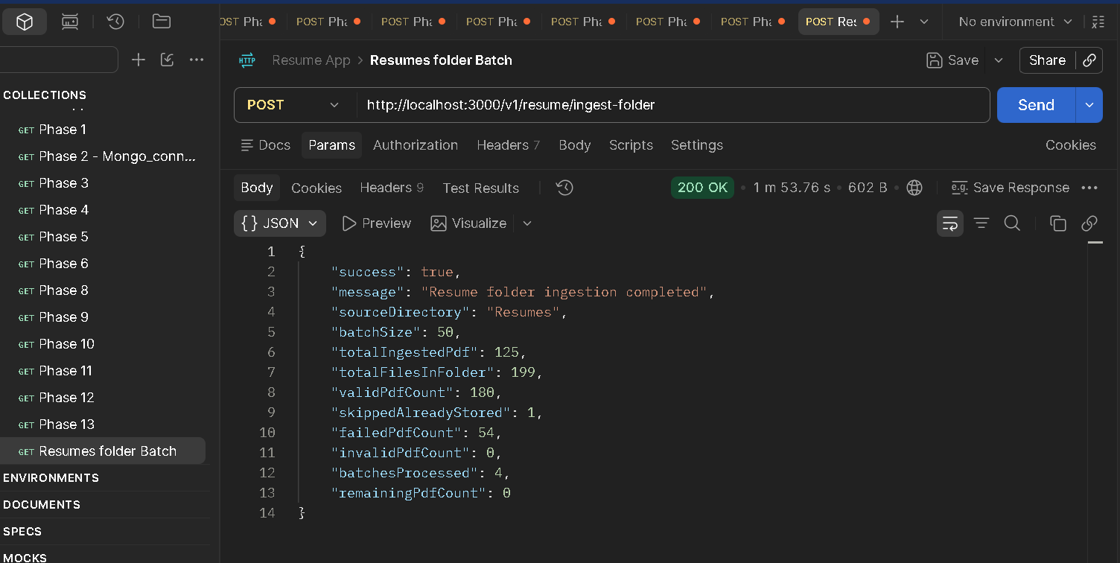

failedPdfCount considers below

- PDF extraction failed
- Text parsing failed
- Mistral embedding failed
- MongoDB insertion failed

Failes when th below issue is seen
- Files with a .pdf extension but invalid PDF content
- PDFs skipped because the same filename already exists in MongoDB

Mongo DB ingested records
